**ZD -Batch Application Transactions Workflow**

Version 1.0

ZD Batch Application ADD Transactions

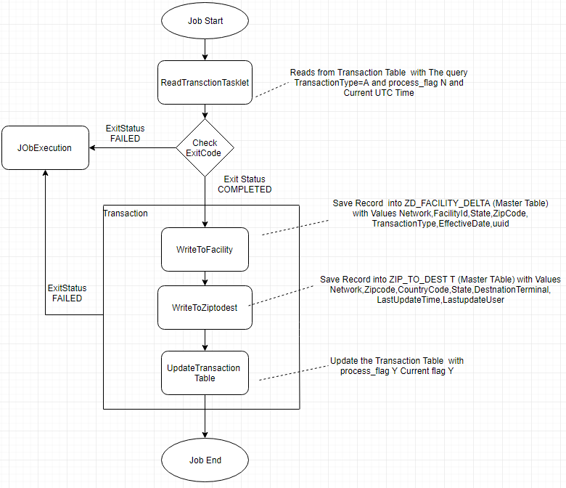

**Modify Transactions**

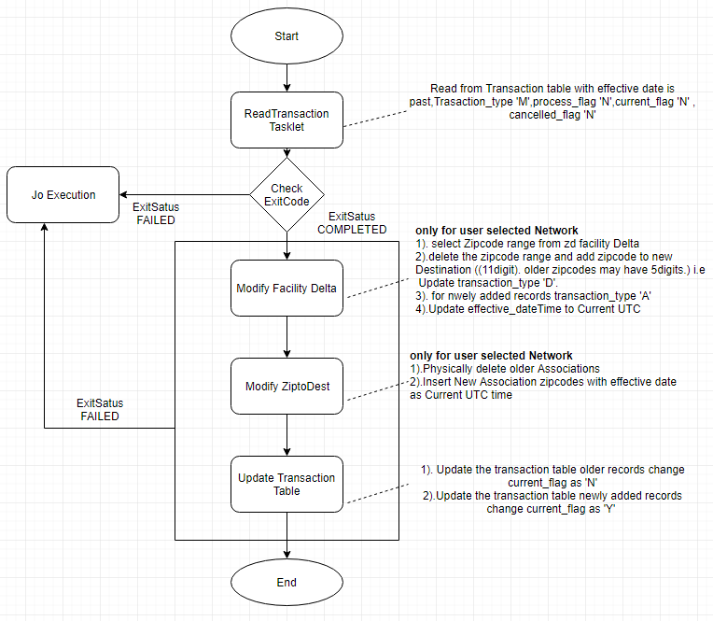

**Delete Transactions**

